Registering for an iLab Account
External Customers

- Go to https://dfci.ilab.agilent.com/account/login and select Register in the upper right-hand corner.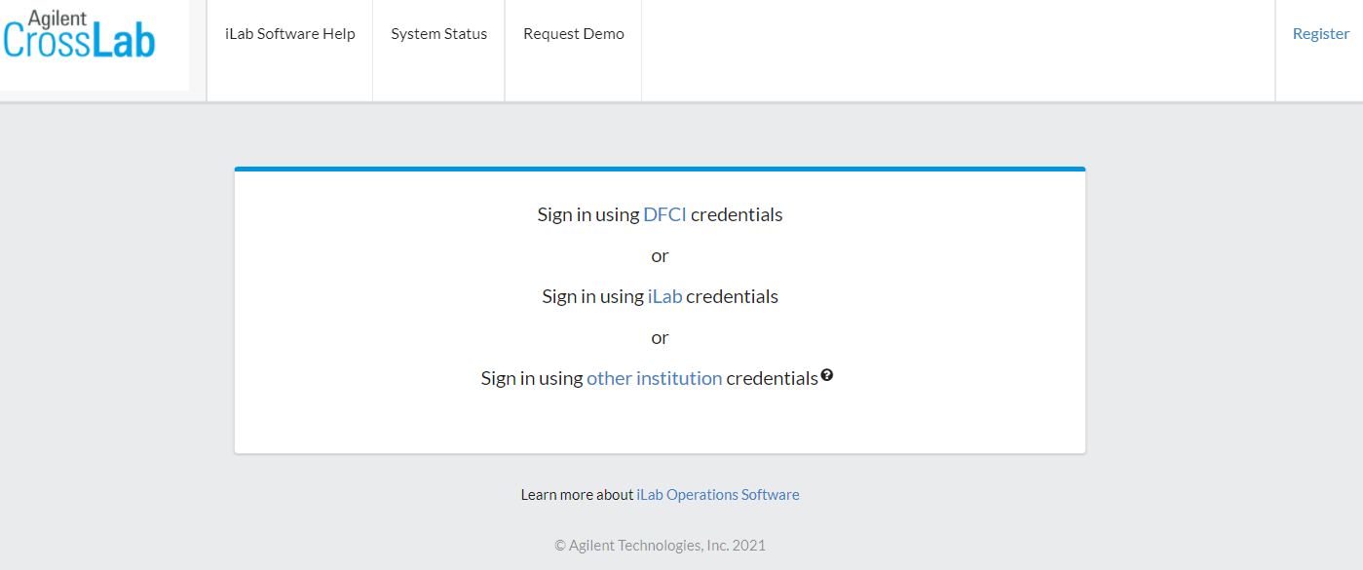

- Two text boxes will appear. External users will select “Register for an iLab account”.
Register for an iLab account
Register with DFCI credentials

- Enter your institutional e-mail address, confirm the CAPTCHA check, agree to iLab privacy and security policies, and select continue. iLab privacy and security policies are available by selecting the hyperlinked texts “privacy” and “security.”
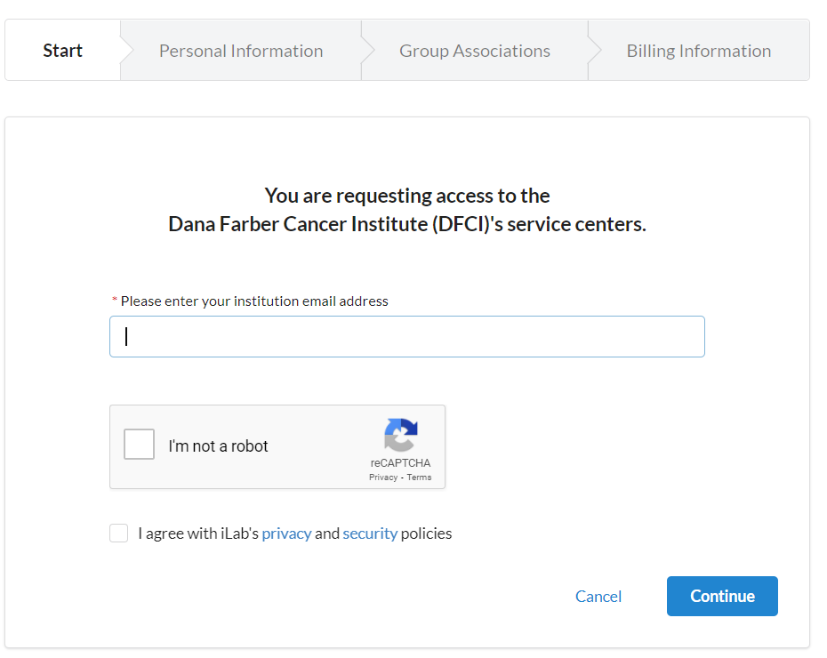

- Complete the personal information tab and select continue. If your institution is not currently associated with iLab, continue writing the complete name of your institution and click the blue highlighted “create new”
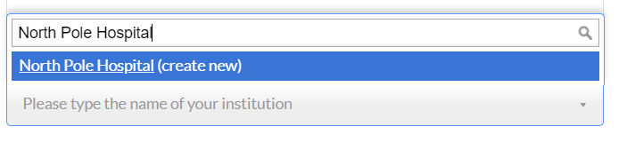

- On the next Group Association Tab, if your institution already exists, select the lab you belong to.
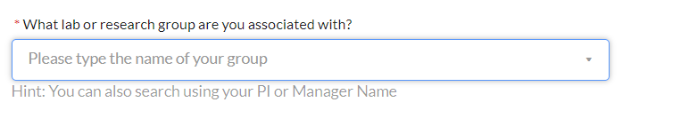

If you need to create a new lab, enter your PI or Lab Manager’s information and be sure to include the information of any financial administrator, grants manager, or staff member who manages lab membership or processes invoices.

The “Group Name” will auto-populate when you click the box

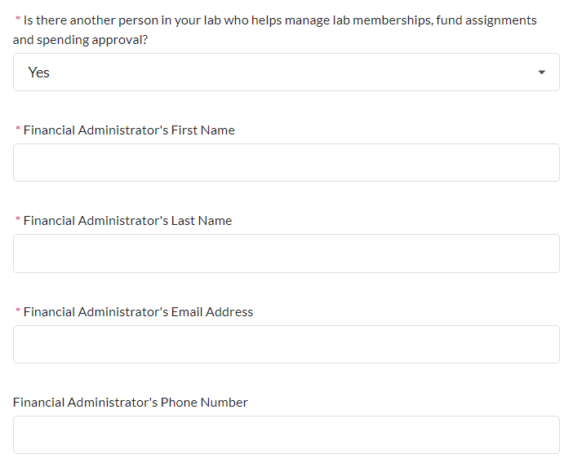
- On the “Billing Information” Tab, enter your institution’s billing information and select Complete.
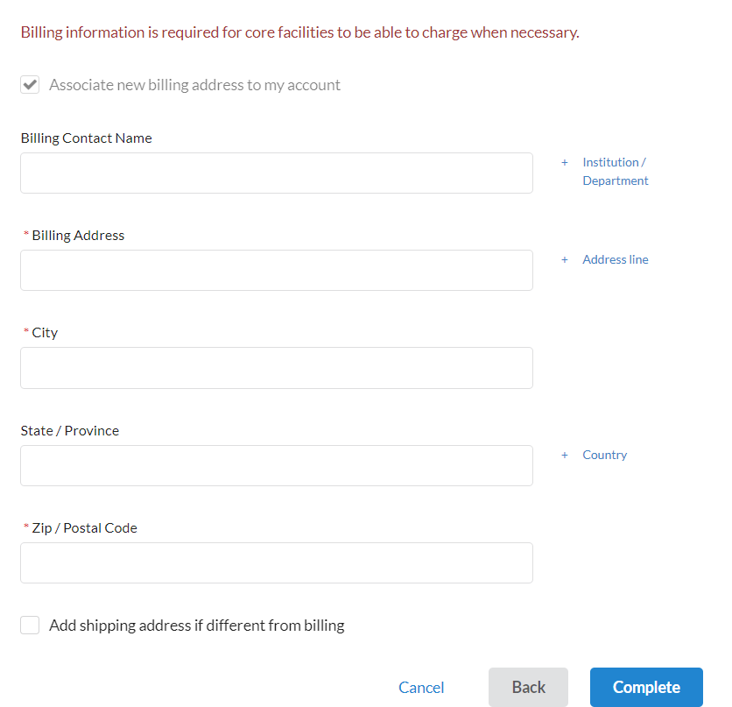

- If all information has been submitted, you’ll reach this screen confirming your request for an account is complete. It will need to be confirmed by the core that this is an appropriate account to create and may take 24 hours to process your request.

Contact ilab-support@agilent.com for questions regarding your account creation.

